**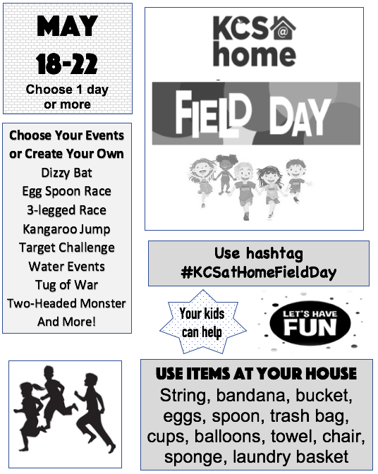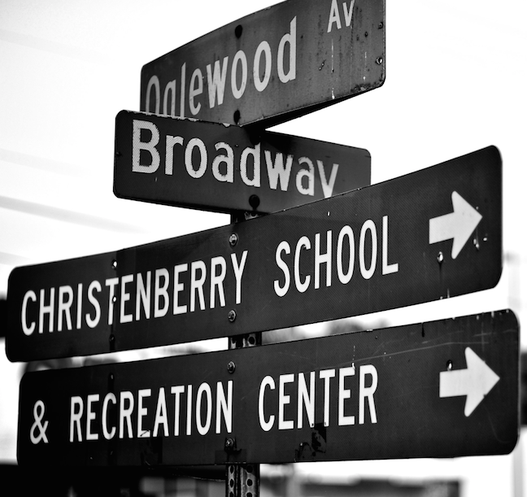

**Drive by and pick up your child’s materials!**

The teachers have bagged up all student materials from their classroom.

Students’ personal belongings & final report card can be picked up May 19, 20, & 21 from 12-2 p.m. in the car rider line.

If you have more than one child, you may pick up on any of the three days. If you have one child, please come on their assigned grade level day.

**Tuesday, May 19-** 4th & 5th Grades

**Wednesday, May 20-** 2nd & 3rd Grades

**Thursday, May 21-** PreK, Kindergarten, and 1st Grades

**\*Please continue to bring library books during May from 8-3 p.m. Tuesday – Thursday.**

**Scholar, Food, and Packet Distributions**

- The last day for resource packets will be ***Wednesday, May 13***.

-The last day for food will be ***Wednesday, May 20***.

-Scholars Guides will be distributed at the **final** food distribution sites, ***May 18 and May 20.***

Guides will also be posted to the KCS @ Home website.

May 11-15

**The Cardinal Press**

**Kindergarten and Voluntary Pre-School Registration**

Please return completed paperwork on **May 12, 13, 19, 20, 26, and 27 from 9:00- 1:00 in the school office**. For ALL new enrollees please bring proof of residence when you return the paperwork. For voluntary Pre-K, you will need proof of income as well.



Please continue to scan or clip box tops while you are home.

**Administration Contact Information:**

Melissa Johnson, Executive Principal

[melissa.johnson1@knoxschools.org](mailto:melissa.johnson1@knoxschools.org)

Tonya Cash, Assistant Principal

[tonya.cash@knoxschools.org](mailto:tonya.cash@knoxschools.org)

Jennie Scott, Assistant Principal

[jennie.scott@knoxschools.org](mailto:jennie.scott@knoxschools.org)

|  |  |
| --- | --- |
| **Date** | **Activity** |
| **March 12** | **21st Century Showcase**  **3:00-4:30** |
| **March 12** | **G3-G5 Field Trip to Urban Brilliance STEM Event for selected students** |
| **March 13** | **End of 3rd Nine Weeks Grading Period** |
| **March**  **16-20** | **SPRING BREAK**  **NO SCHOOL** |
| **March 26** | **Report Cards**  **GO HOME** |
| **March 27** | **Honors Program**  **Grades 1-5** |
| **March 30- April 3** | **Book Fair and Goodwill Sack Drive** |
| **April 2** | **International Night**  **@ 5:00 p.m.** |
| **April 3** | **Dance-A-Thon**  **during ENCORE** |

**Christenberry Elementary School – Where Students Come FIRST!**